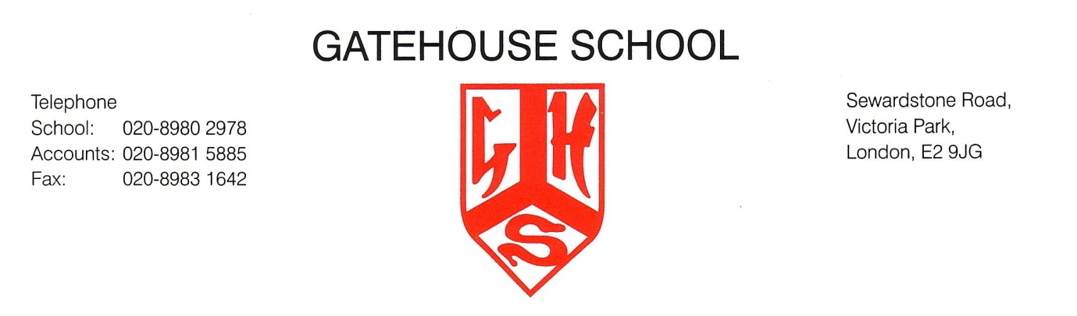
Individual Music Tuition at Gatehouse School

We offer a wide variety of musical instrument tuition at Gatehouse. These lessons are 30 minutes long, at £23 per lesson, paid directly to the instrumental teacher. Lessons take place during the school day, and our highly-trained instrumental teachers rotate their timetables weekly to ensure children do not miss the same lesson twice in a row. Please note children will be added to a waiting list if instrument spaces are full.

Please see the available instruments and teachers below:

Drum Kit | Mr Sam Jesson | Year 2+
Flute  Saxophone  Clarinet  Recorder | Mr Thom Hosken | Year 1+
Trumpet  French Horn | Mrs Chrissie Ranson-Thompson | Year 2+
Violin  Viola | Ms Hazel Brooks | Year 1+
Cello | Ms Meera Raja | Year 2+
Guitar  Ukulele | Mr Grant Dowse | Year 1+
Piano | Mr Oliver Payne  Ms Helen Nicholas  Mr James Buckham  Mr James Green | Year 1+
Orchestral Percussion | Mr James Green | Year 2+
Singing | Mrs Rachel Falaise | Year 1+

Please complete the slip below and return it to the Head of Music via the school office or email admin@gatehouseschool.co.uk.

I would like my child to be added to the individual music tuition waiting list:

Child’s name……………………………………..…………………………………………………………………… Class…………….

Instrument(s)……………………………………………………………………………….

Parent’s name ……………………………………………………………………………..…………….

Parent Tel ……………………………………………………….…. Email …………………….…………..………………………

Signature ……………………………..………………………………...... Date ……………………………

