14.05.2021

Dear Parents,

We wanted to inform you that next week, the week beginning 17th May, we are going to be celebrating ‘Eco Travel to School Week'.

It would be great if you could join us in travelling to school in an eco-friendly way for the entirety of next week. Some of our Eco-Warriors have thought of some great ways to get to school that are environmentally friendly which include: cycling, walking, using public transport, scooters, skating or sharing a car with someone in the same bubble.

Information about 'Eco Travel to School Week' has been shared with all the children in school. In their classes, they have discussed why it is important to find eco-friendly ways of travelling to school and they have come up with some suggestions and ideas that they can share with you!
We have attached a couple of posters that some of our eco-warriors have made below :)

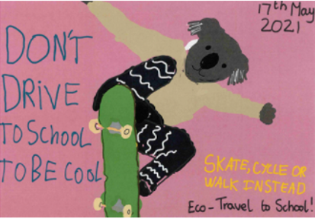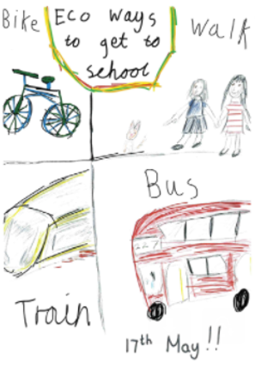

If you would like to, please do send us pictures of you travelling to school in an eco-friendly way so that we can share them on our social media. Please email these photos to admin@gatehouseschool.co.uk using the subject line 'Eco travel'.

Many thanks,

Ms Savva and Miss Hallworth

