FRIENDSHIP

GOALS
2B’S ASSEMBLY

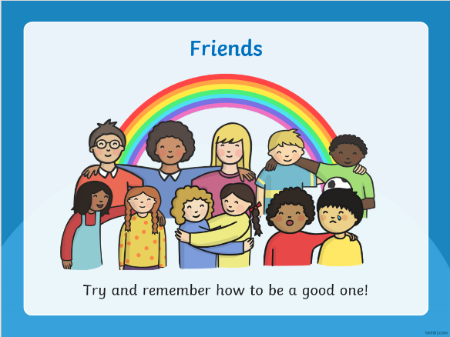

This week 2B’s assembly was about friendship. We looked at some qualities we think a friend should have. We all know that friendship is an important part of life. It requires constant work to make it worthwhile. We also thought about how we can be friends with everyone at Gatehouse. We sang ‘Ain’t no mountain high enough’ and ‘With a little help from my friends’. It was lovely to see the whole school along with parents participating too!
2B finished off their assembly with a thought for everybody to think about when we consider what friendship truly means:
To be a friend is to show someone that you care!

