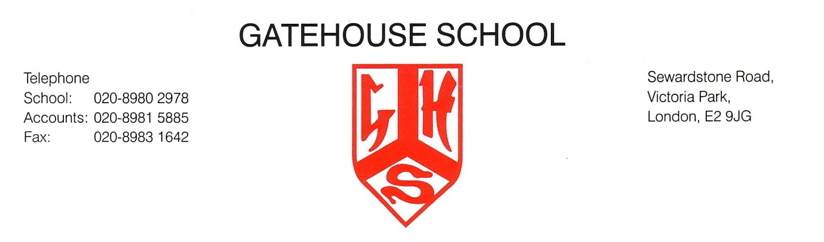
Individual Music Tuition at Gatehouse School

DRUM  KIT | Mr Jesson | Year 2+ | VIOLIN  VIOLA | Ms Brooks | Year 1+
FLUTE  SAXOPHONE  CLARINET  RECORDER | Mr Hosken | Year 1+ | GUITAR UKULELE | Mr Dowse | Year 1+
PIANO | Mr Payne,  Ms Nicholas  Mr Buckham  Mr Green | Year 1+ | SINGING | Mrs Falaise | Year 1+
CELLO | Ms Drury | Year 2+ | TRUMPET  FRENCH HORN | Ms Ranson | Year 2+
ORCHESTRAL PERCUSSION | Mr Green | Year 2+

Please complete the slip below and return it to Head of Music via the school office or email admin@gatehouseschool.co.uk

I would like my child to be added to the individual music tuition waiting list:

Child’s Name….……………………............................. Class………

Instrument(s)……………………………………...…………

Signature……………………………………….…….….. | Date.....................
Parent Tel: email:

