Dear Parents,

The annual poetry competition has been and gone and the standard of entries was incredible yet again!

As a year 4 and 5 English teacher, I  see such a high standard of work, yet the confidence, effort and dramatisation from all age ranges during the performances never fails to amaze me.

The audience were on the edge of their seats, with children from Reception to Year 6 reciting lengthy poems, which they had learnt off-by-heart, using actions, props and personality. Some of the older children had even written their own poems, showing a great deal of understanding of poetic technique and humour.

I can't believe that 2018 will bring even more talent and imagination than we saw this year, but I have no doubt that it will!

Thank you all for your support,

Miss Holt

**The results were:**

Reception:

1st - Barnaby Rogers

2nd - Paloma Gonsalves

3rd - Hector Dally

Year 1:

1st - Ami To

2nd - Ash Koby-Hirschmann

3rd - Dante Olmeo

Year 2:

1st - Xavier Keogh

2nd - Hugo Elek

3rd - Tamara Alloo

Year 3:

1st - Otis Mackenzie

2nd - Heath Boardman

3rd - Xavier Gray

Year 4:

1st - Alex Keogh

2nd - Tess Noblet

3rd - Milo Martin

Year 5:

1st - Ruby James

2nd - Daisy Poole

3rd - Sam Allilaire and Ralf Jungling

Year 6:

1st - Sonny Gray

2nd - Olivia Ross-Bell

3rd - Charlotte Houseley

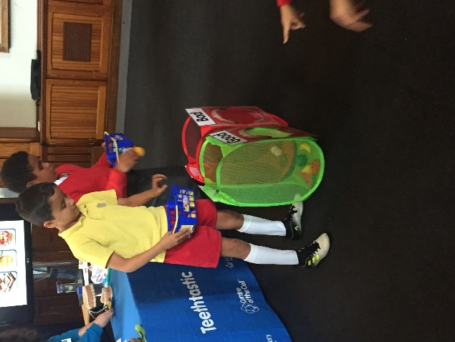

Y3 visit to the Centre of the Cell. You may want to use them for your newsletter. The children learnt about how their teeth formed and how to look after them.

