Dear Parents,

I hope that you are looking forward to the Christmas period. With only a couple of days to go before the Autumn Term comes to an end, I thought you may like to see some of the many highlights of our very busy and productive term.

My thanks to our GPA who have purchased our super Christmas lights in the Wallbank Hall and who have organised two hugely successful events this term; the Autumn party and the Christmas Fair. Thank you also to our parents for your support and of course, my thanks to our pupils for their hard work in all areas of school life.

We wish you all a Merry Christmas and a Happy New Year!

Mr A Noakes

**Housekeeping and Reminders**

**Parent Survey**

Thank you to all the parents who have completed our Parent Survey, your opinions and comments are hugely helpful in evaluating and determining where we can improve and move Gatehouse forward. If you have not completed the survey *please, please* can I ask you to do so; it only takes 5 minutes! The survey closes on **22nd December 2017.** The link is below:

<https://www.eSurveysPro.com/Survey.aspx?id=b1fcc859-908f-41be-9fd6-f58208044827>

**Uniform**

One of the aspects of school life which a large majority of pupils, parents and teachers have all expressed an opinion on is the wearing, or rather not wearing, of school uniform. We seem to have all sorts of different types of clothing being worn to and from school and are therefore looking to ensure our pupils are smart and well-turned out so they can feel proud to wear the Gatehouse uniform. We will be clamping down on uniform from next term and to help you know what we expect pupils to be wearing please do find attached a school uniform list (to include PE kit) and photographs of our autumn/winter uniform to show many of the items in the list. I know teachers would all be very grateful of your support in this regard.

*Gatehouse Uniform is available from:*

*Khalsa Schoolwear*

*388-390 Bethnal Green Rd, Bethnal Green, London E2 0AH*

*Tel: 020 7729 3286*

[*http://www.khalsaschoolwear.co.uk/*](http://www.khalsaschoolwear.co.uk/)

**Cold Weather**

Please may I remind you that as the weather becomes colder all pupils should bring their grey duffle coat to school to be worn during playtime. Any pupil without a coat will be kept inside.

**Pupil Supervision**

Please may I remind parents and carers that pupils are not to be left unsupervised at the end of the school day in the playground.

**Punctuality**

I am writing to politely remind you of the timings of the start of the school day:

0830       Gates open

0850       Registration

0855       Assembly commences

Please may we ask that children are in school on time for registration each day in order that we can ensure all pupils are correctly registered and staff know who is on-site.

Please be aware that our gates close at 8.50am and therefore any pupil arriving late must report to the Office.  Due to Health and Safety, parents are not permitted to escort their child/ren to their classroom and therefore must leave them at the Office.  A member of the Office staff will then escort the pupil/s to their classroom.

Whilst I understand that there may be unforeseen occasions when pupils are running late, please may I remind you that time out of school affects learning and achievement for the latecomers and the class.

With thanks in advance.

**Gatehouse School, Outward Bound and the Duke of York**

For many years Gatehouse School has always supported the Outward Bound Trust for the valuable school residential trips and activities they offer. We were delighted to be invited to a conference hosted by the Duke of York recently to provide input to the development of their programmes and to learn even more about the exciting initiatives the Trust are planning to offer. It was a wonderful opportunity to help ensure event more experiences for our Gatehouse pupils in the years to come and not at all a displeasure to do so at Buckingham Palace!

**Term Dates**

The term dates for 2018/2019 have now been published and you will receive a copy of these with your child’s school report. We will be updating the website very shortly.

**Website**

We have recently uploaded lots of fantastic Christmas event photographs on to the parents’ area of the website. We are in the process of redesigning our website which we hope will be up and running during next term. Therefore, during this period, should you be unable to find up-to-date information, or have any queries please do contact the office.

**Performances**

Please find below a selection of some recent Christmas performances along with some photographs. Please do visit the website to see the many additional photographs.

**1W Assembly**

On 9th November, IW performed their class assembly about the Three Kangaroo Gruffs. It was an Australian version of the Three Billy Goats Gruff, which included Bunyip and Kangaroos instead of trolls and Billy Goats. The children sang Kangaroo Gruff songs to complement the play. Well done, 1W!

**Nursery Nativity**

The festive season got off to a wonderful start on Friday, 1st December when the Nursery presented their Nativity play. A big thank you to parents for providing such delightful costumes and congratulations to all the children on their first Gatehouse performance!

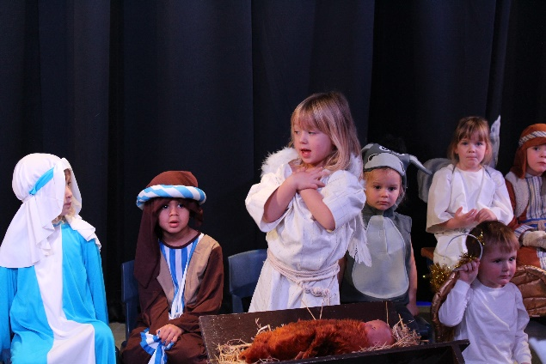

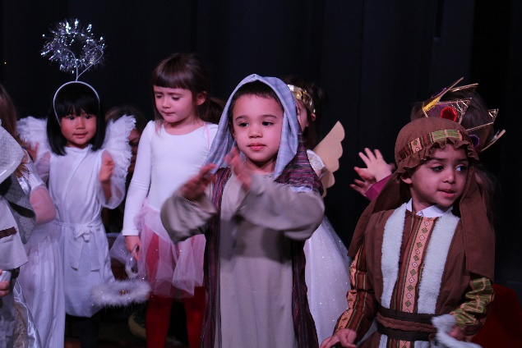

**Reception Christmas Performance**

Well done to all the Reception pupils for their wonderful Christmas Assembly performance.

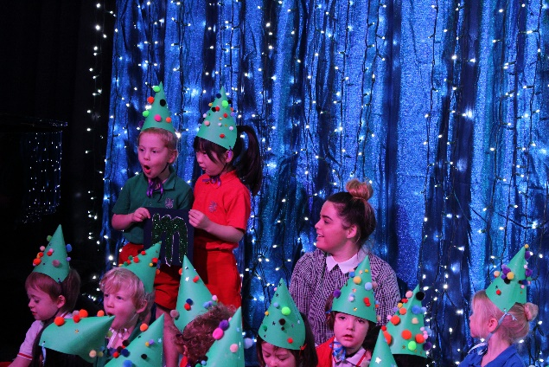

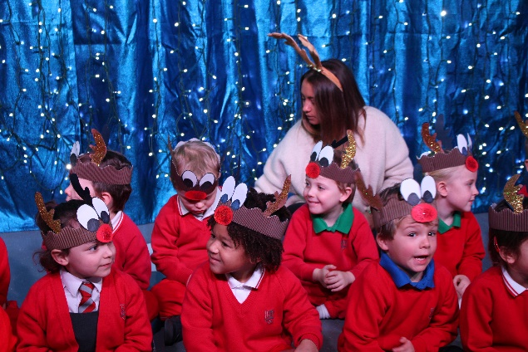

**Year 1 Christmas Assembly**

On the 7th of December, Year 1 participated in an International Gatehouse School Christmas Assembly. The play included some playful banter about our amazing school during the festive Christmas period and not to mention those smart…. and kind…. and happy… and clever….. and beautiful teachers and assistants!

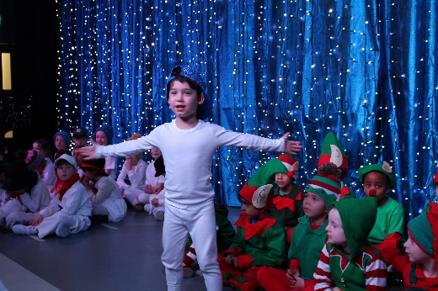1K’s were the amazing snowmen singing ‘Frosty the Snowman’. 1D’s were the extraordinary elves who sang Jing Bells in French and of course those awesome 1W’s dressed up as Aussie Santas and singing about what it would be like to be a Santa living in Australia! We all enjoyed the play and the children had a great time on stage! Well done to all the Year 1’s for their brilliant performance.

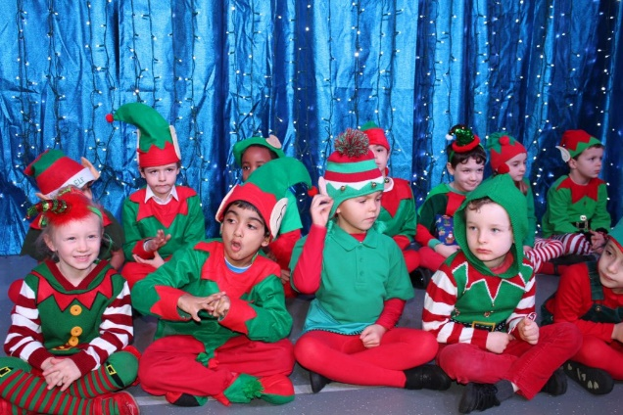

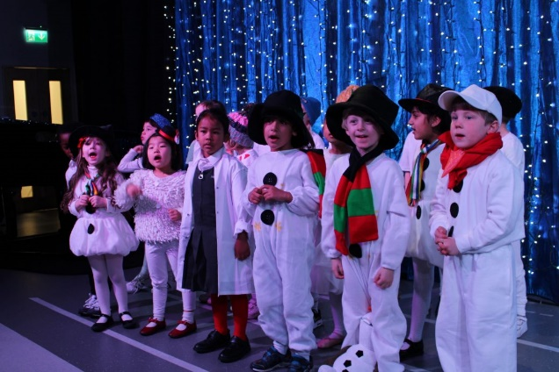

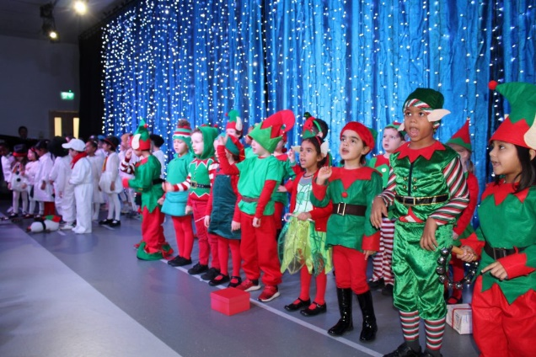

**Year 2 Christmas Carol Assembly**

Year 2 thoroughly enjoyed performing their Christmas Assembly. It included the famous poem The Night Before Christmas. They sung their hearts out and made us all feel very Christmassy!

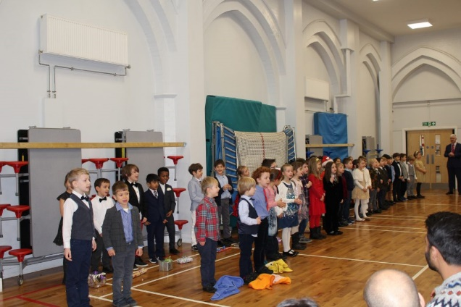

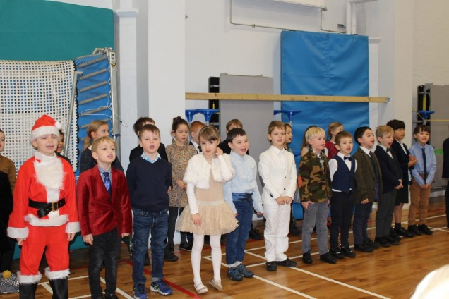

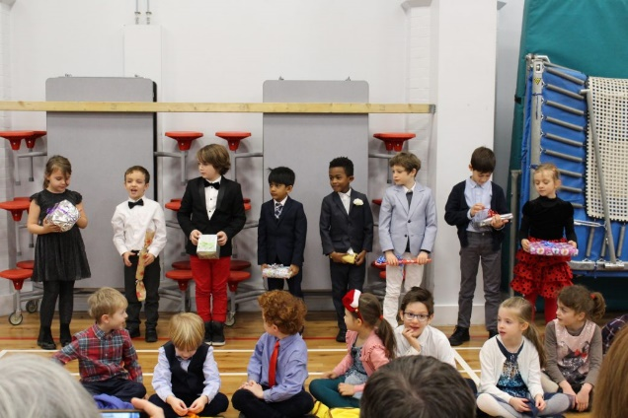

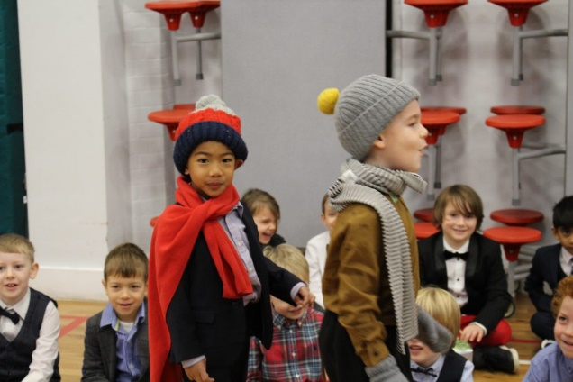

**Christmas Concert**

Today parents of our Upper Juniors were treated to a wonderful Christmas spectacular. The Music Department put on a fantastic show with performances from the Orchestras, Choirs and many other ensembles. Well done to all the pupils for their hard work!

[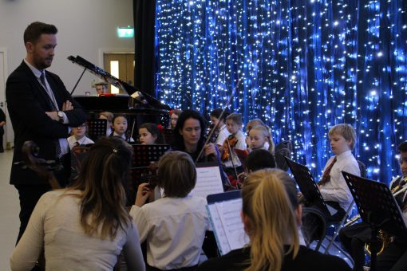](http://www.gatehouseschool.co.uk/wp-content/uploads/2017/12/IMG_6438.jpg)

[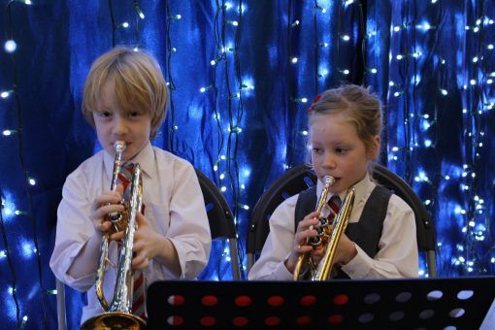](http://www.gatehouseschool.co.uk/wp-content/uploads/2017/12/IMG_6430.jpg)

**Science News**

**Science Club**

Science Club have been busy this term making Volcanoes

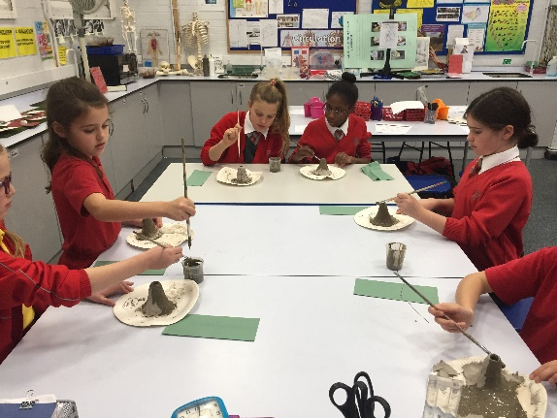

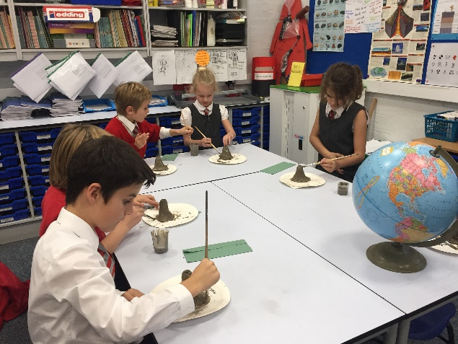

**Science Exhibition**

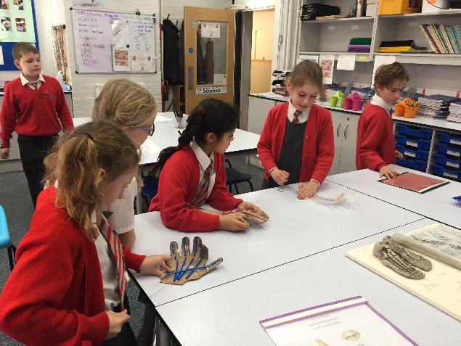

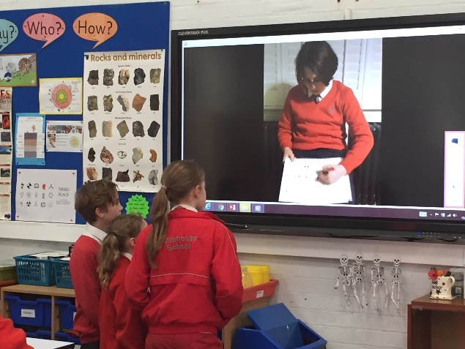

**Science in Year 3**

Y3 have been making edible models of the earth.

