Dear Parents,

Welcome to the second half of the Autumn Term, last half term was a very busy half term.  Outside of timetabled lessons, our pupils have attended various school trips, including all year groups visiting Kenwood, played in many fixtures both home and away, visited our Book Fair, competed in our Poetry competition, collected for our Harvest Donation; the list is ongoing. Please find a selection of our Gatehouse news below, which I hope you enjoy.

My congratulations to our existing and new children, all of whom have settled well and are enjoying the new classrooms and Library.  The building works have continued over half term and our Year 3 and Year 6 have moved into their new classrooms.

I hope you all had a restful and enjoyable half term break and look forward to seeing many of you over the weeks to come.

**Polite Request**

I have received a request from some of the residents of Rosebery House who have been experiencing disruption to access of paths. Please may I ask, where possible, if noise and disruption to the residents could be reduced.

My thanks in advance.

**School Nurse**

I am delighted that Nurse Freya has joined Gatehouse School.  Nurse Freya is located in the Undercroft in our new medical room which is next to the IT suite.  So far many pupils have visited Nurse Freya to say 'hello'.  Parents are also very welcome to visit her or contact her via email with any queries.  Nurse Freya not only looks after the well-being of our pupils but also provides an important link between school and home.   Should you wish to email Nurse Freya please do via: [nurse@gatehouseschool.co.uk](mailto:nurse@gatehouseschool.co.uk)

**Medical and Contact Forms**

Please can I remind you that any medical forms and/or contact forms need to be returned to the Office as soon as possible. This is vital for us to ensure that the records we hold for our pupils are up-to-date.

**Parental Survey**

I will be asking all of our parents to complete a parental survey; we always value your opinions and your feedback is crucial in helping to move Gatehouse School forward.  By working together with you and our community we continue to make Gatehouse School outstanding.

**Housekeeping and Reminders**

Regrettably, due to health and safety please may I remind you that the playground equipment is not to be used either before school or after school.

**Annual Poetry Competition**

Last week we hosted our annual poetry competition which was not only a huge success but the standard of our pupil’s entries were incredible yet again!

As a Year 4 and 5 English teacher, I see such a high standard of work, yet the confidence, effort and dramatisation from all age ranges during the performances never fails to amaze me.

The audience were on the edge of their seats, with children from Reception to Year 6 reciting lengthy poems, which they had learnt off-by-heart, using actions, props and personality. Some of the older children had even written their own poems, showing a great deal of understanding of poetic technique and humour.

I can't believe that 2018 will bring even more talent and imagination than we saw this year, but I have no doubt that it will!

Thank you all for your support

*Miss Holt*

**The results were**

**Reception**

1st - Barnaby Rogers

2nd - Paloma Gonsalves

3rd - Hector Dally

**Year 1**

1st - Ami To

2nd - Ash Koby-Hirschmann

3rd - Dante Olmeo

**Year 2**

1st - Xavier Keogh

2nd - Hugo Elek

3rd - Tamara Alloo

**Year 3**

1st - Otis Mackenzie

2nd - Heath Boardman

3rd - Xavier Gray

**Year 4**

1st - Alex Keogh

2nd - Tess Noblet

3rd - Milo Martin

**Year 5**

1st - Ruby James

2nd - Daisy Poole

3rd - Sam Allilaire and Ralf Jungling

**Year 6**

1st - Sonny Gray

2nd - Olivia Ross-Bell

3rd - Charlotte Houseley

**Year 3 Visit to the Centre of the Cell**

Year 3 visited the Centre of the Cell and learnt about how their teeth are formed and how to look after them.

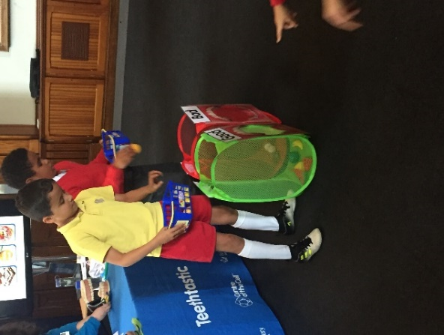

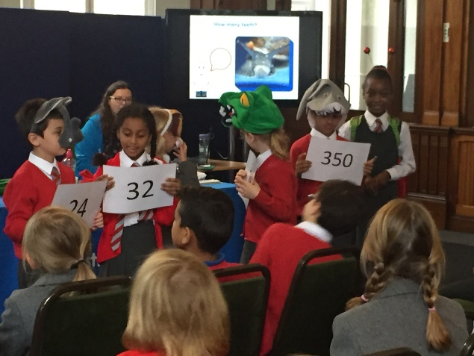

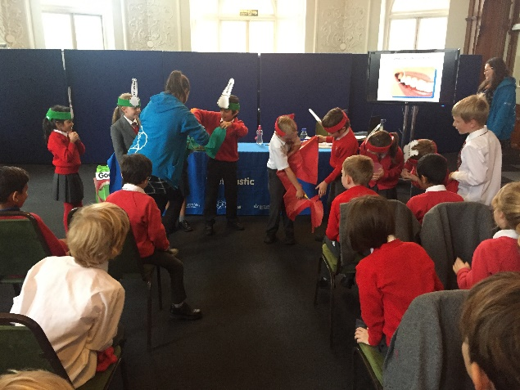

**Gatehouse Book Fair**

I am delighted to advise that Gatehouse parents and pupils spent an amazing £1289.37 at the Book Fair. I really shouldn't be surprised, as I am fully aware of the School's love of reading!

We receive 60% in commission on our sales from Scholastic, so the library now has £773.00 to spend on replenishing stock in your library.

Thank you all for your tremendous support.

*Mrs Louise Gately - Librarian*

**Harvest**

Our thanks to all our parents who generously donated to First Love Foundation, Tower Hamlets Food Bank.  We have been overwhelmed with your generosity and I can confirm that Barney, from First Love, advised that Gatehouse’s donation was the greatest he had ever picked up!

**Y6 visits the Natural History Museum**

Year 6 took part in an evolution workshop at the Natural History Museum.  They were able to test their knowledge of adaptation and explored the evolutionary tree of our own species in more detail.

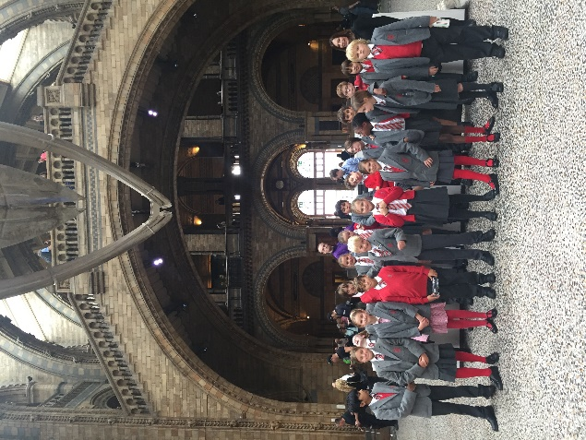

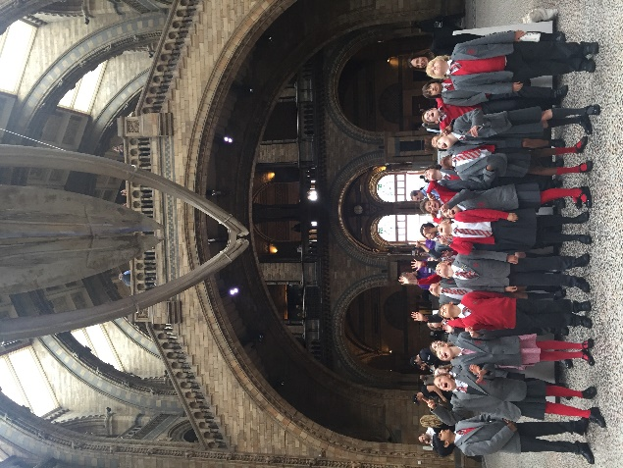

Not only did Year 6 thoroughly enjoy the trip but the Museum’s workshop leader commended Year 6 for their behaviour and knowledge. Well done Year 6!

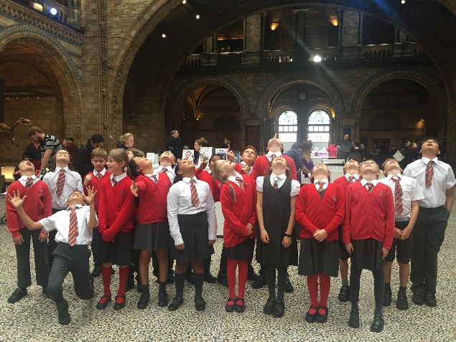

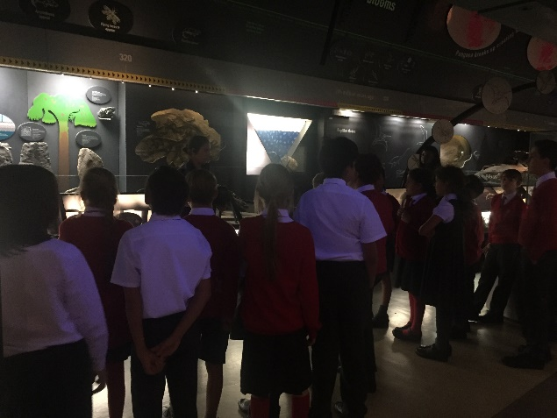

**Year 3 and 4 Music Performances**

Pupils in Year 4 are busy perfecting their performance pieces for their grade 1 and 2 acting exams which will take place before the end of term. With a selection of kitchen farce, Dahl, murder mystery and a rapping donkey (!), the children are engaged and enjoying this extracurricular activity. Details for when the Year 3s can get involved in this exciting opportunity will follow before Christmas.

**Dyslexia Awareness Week**

Monday 2nd of October saw the start of Dyslexia Awareness Week. The school raised awareness by asking the dyslexic children to help make a display about dyslexia and research some inspirational dyslexic people. They found many inspirational dyslexics; including Albert Einstein, Steve Jobs, Darcy Bussell and Richard Branson! This helped show how many successful, creative and innovative people are dyslexic. Please come up and see our display outside the SEN Department and spot our inspirational dyslexic students too. In our PSHE lessons the children learnt about dyslexia through a Newsround film which followed a young boy and his experiences of being dyslexic. Our own dyslexic pupils then did a fantastic job describing living life as a dyslexic to their class.